South Sudan

## Political Stability Estimate Data

The data set shows the political stability estimate of the country for a given year and its classification in four categories (unstable, moderately unstable, moderately stable, stable).

## # A tibble: 19 x 5  
## country iso3c date stability stabilityCategory4  
## <chr> <chr> <dbl> <dbl> <chr>   
## 1 South Sudan SSD 1996 0.990 moderately stable   
## 2 South Sudan SSD 1998 0.990 moderately stable   
## 3 South Sudan SSD 2000 0.990 moderately stable   
## 4 South Sudan SSD 2002 0.990 moderately stable   
## 5 South Sudan SSD 2003 0.990 moderately stable   
## 6 South Sudan SSD 2004 0.990 moderately stable   
## 7 South Sudan SSD 2005 0.990 moderately stable   
## 8 South Sudan SSD 2006 0.990 moderately stable   
## 9 South Sudan SSD 2007 0.990 moderately stable   
## 10 South Sudan SSD 2008 0.990 moderately stable   
## 11 South Sudan SSD 2009 0.990 moderately stable   
## 12 South Sudan SSD 2010 0.990 moderately stable   
## 13 South Sudan SSD 2011 -1.43 highly unstable   
## 14 South Sudan SSD 2012 -1.16 highly unstable   
## 15 South Sudan SSD 2013 -1.73 highly unstable   
## 16 South Sudan SSD 2014 -2.65 highly unstable   
## 17 South Sudan SSD 2015 -2.38 highly unstable   
## 18 South Sudan SSD 2016 -2.42 highly unstable   
## 19 South Sudan SSD 2017 -2.46 highly unstable

## Political Stability Estimate Plot

The plot shows the trends of stabilization and destabilization for the each country.

A stabilization trend can be classified as absolute, if the stability scores move from unstable or moderately unstable to moderately stable or stable (that is, crossing up the red line). The trend can be considered relative, if the scores remain in the same positive or negative areas. Similarly, a destabilization trend can be classified as absolute, if the stability scores move from stable or moderately stable to moderately unstable or unstable (that is, crossing down the red line). The trend is considered relative, if the scores remain in the same positive or negative areas.

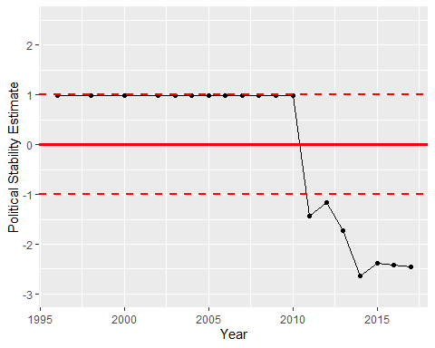

Political Stability Trend